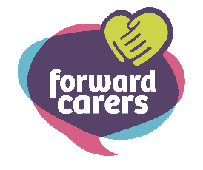
Application Form for a Tablet
First and Last Name: _______________________________________________________
Address: __________________________________________________________________
___________________________________________________________________________
___________________________________________________________________________
Postcode: _________________________________________________________________
Email Address: _____________________________________________________________
Phone number: _____________________________________________________________
Date of Birth: _______/_____/__________________________________________________

Why do you need a tablet?

If you are successful in your application, how will you use your tablet?

What difference will having a tablet make to you and your life?

What difference will having a tablet make to you and your life?

Please submit your application by Sunday 20th October 2024. Please return this application to: Forward Carers, TouchBase Pears, 750 Bristol Road, Selly Oak, Birmingham, B29 6NA.

Thank you for your application, we will be in touch to let you know the outcome.

