

Be Empowered…
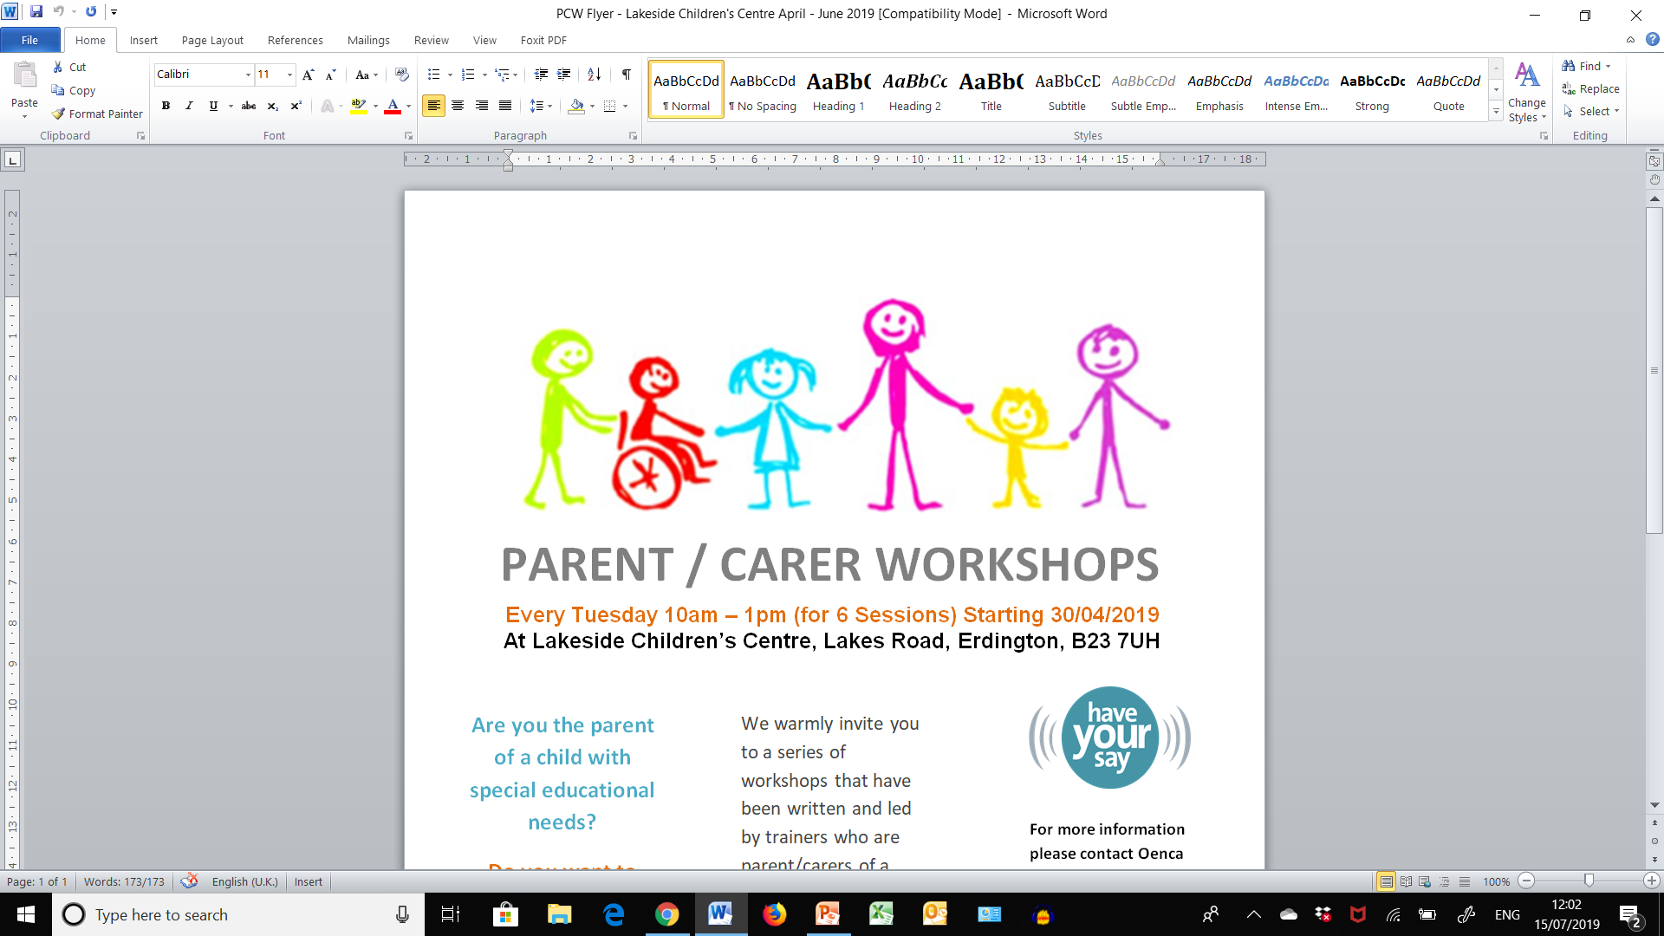
Be Empowered Workshop – Early Support Programme for SEND Parent Carers
Booking form for ONLINE Be Empowered Workshops
Workshop Details:

Workshop Dates: Wed 22nd April; Wed 29th April; Wed 6th May; Wed 13th May; Wed 20th May but NOT 27TH MAY AS HALF TERM and finally Wed 3rd June 2020

Workshop Times: 6pm - 9pm

PLEASE NOTE IN ORDER TO ACCESS THESE WORKSHOPS ONLINE YOU WILL NEED A PC OR LAPTOP AT HOME WITH A CAMERA

Please note there is no charge for these workshops.

Please complete all sections in BLOCK CAPITALS.
To ensure that we can process your form swiftly please ensure the form is fully completed and the consent overleaf is signed and dated.

Your Details:

Parent Carer Name…………………………………………………………………………………………………………………………………….

Address……………………………………………………………………………………………………………………………………………………..

Postcode………………………………………………………Telephone Number……………………………………………………………….

Email Address……………………………………………………………………………………………………………………………………………….

Age of your child(ren) and their individual additional needs

……………………………………………………………………………………………………………………………………………………………………..

Any special requirements or access requirements:

……………………………………………………………………………………………………………………………………………..........................

Name: ………………………………………………………. Signature: …………………………………………………….Date:………………….

Please read Course Booking Terms and Conditions overleaf. Please email the signed consent and this booking form by Wed 1st April to either: Sarah.Adams@birmingham.gov.uk Tel: 07827 082 751 or
Oenca Fontaine (Parent Engagement Consultant) oenca@innerdimensions.co.uk

TERMS AND CONDITIONS

ALL EYIS -EARLY SUPPORT SERVICE COURSES
On receiving this booking we will assign available place/s. If bookings are received after the deadline, places may not be available and you may be asked to join a waiting list. Whilst every effort will be made by EYIS - Early Support Service to ensure places and keep the dates and venues as advertised, we reserve the right to amend or cancel courses without notice. We will make every effort to inform you in advance if possible. EYIS - Early Support Service does not accept any liability whatsoever, if for whatever reason, the course does not take place.

CONFIRMATION
Bookings will be confirmed and joining instructions will be sent to you.

RESERVING A PLACE AND CANCELLATION CONDITIONS
By entering details on the booking form the delegates confirm they have read, understood and accepted the terms and conditions and are able to attend on the dates specified.

Please contact us as soon as possible if you need to cancel so the place can be offered to someone else.

EQUAL OPPORTUNITIES
EYIS - Early Support Service is committed to equal opportunities in training and professional development and we positively welcome course delegates irrespective of their gender, race, disability, colour, ethnic or national origin, nationality, sexuality, marital status, responsibility for dependents, religion, trade union activity and age. EYIS - Early Support Service will not accept any form of discrimination at any time during the event.

CONSENT

CONSENT – TO BE COMPLETED AND SIGNED BY ALL PARENTS / CARERS/ PROFESSIONALS
I agree to Birmingham City Council (BCC) Early Years Inclusion Support (EYIS) processing personal details and contact information and I understand that both paper and electronic records may be kept as a result of my attendance on the ‘Be Empowered’ Workshops and that any records will be kept securely and destroyed safely in accordance with BCC Document Retention and Deletion Schedule.
I understand that information (for example my name, address, phone number, email address) will only be shared with course facilitators as a result of attending the ‘Be Empowered’ Workshops. This will be done in accordance with Birmingham City Council’s Information Sharing Protocols. This will only be information that is relevant and necessary, shared with people who need that information and, when there is a specific need for that information to be shared at that time.
By signing this form I give explicit consent for BCC EYIS to communicate with me including by secure email.
I understand that as part of the General Data Protection Regulations I have a right to request a copy of the information BCC holds about me. For more information, I can contact BCC’s Data Protection Officer at the Corporate Information Management Team, PO Box 16366 Birmingham email: infogovernance@birmingham.gov.uk
I understand that I can access the BCC Privacy Notice at www.birmingham.gov.uk/info/20154/foi_and_data_protection/384/privacy_statement/1
Name (please print):

Signed:

Date:

